Department of Computer Engineering

Practical - 12

Practical Title: Event Management CRUD with Poster Upload and File Validation

Problem Definition: Develop event management functionality for admin users. Admin can add, view, update, delete, and upload event posters with server-side file type and file size validation.

Theory :
- Are add, update, and delete functionalities implemented correctly?
Yes. Admins can create events with title, category, description, date, venue, and poster; modify existing events with optional poster replacement (old file unlinked); and delete events.

Is the UI linked with the database correctly?
Yes. A responsive card layout displays events with poster images, category badges, formatted dates, venue info, and action buttons — all queried dynamically from MySQL.

Are poster uploads validated for type and size?
Yes. File Size: Limited to 2MB. MIME Type: Verified using finfo_file() to ensure authentic images (image/jpeg, image/png, image/webp), preventing executable spoofing via extension manipulation.

What upload security extensions are included?
Files are renamed using bin2hex(random_bytes(8)) . '_' . time() to prevent path traversal and collisions. PHP execution is disabled inside uploads/ via an .htaccess rule (php_flag engine off).

Implementation / Output / Result
// Server-Side MIME Validation (finfo)
$finfo = finfo_open(FILEINFO_MIME_TYPE);
$mime = finfo_file($finfo, $file['tmp_name']); finfo_close($finfo);
if (!in_array($mime, ['image/jpeg','image/png','image/webp']))
$errors[] = "Invalid file type. Only JPG, PNG, and WebP allowed.";

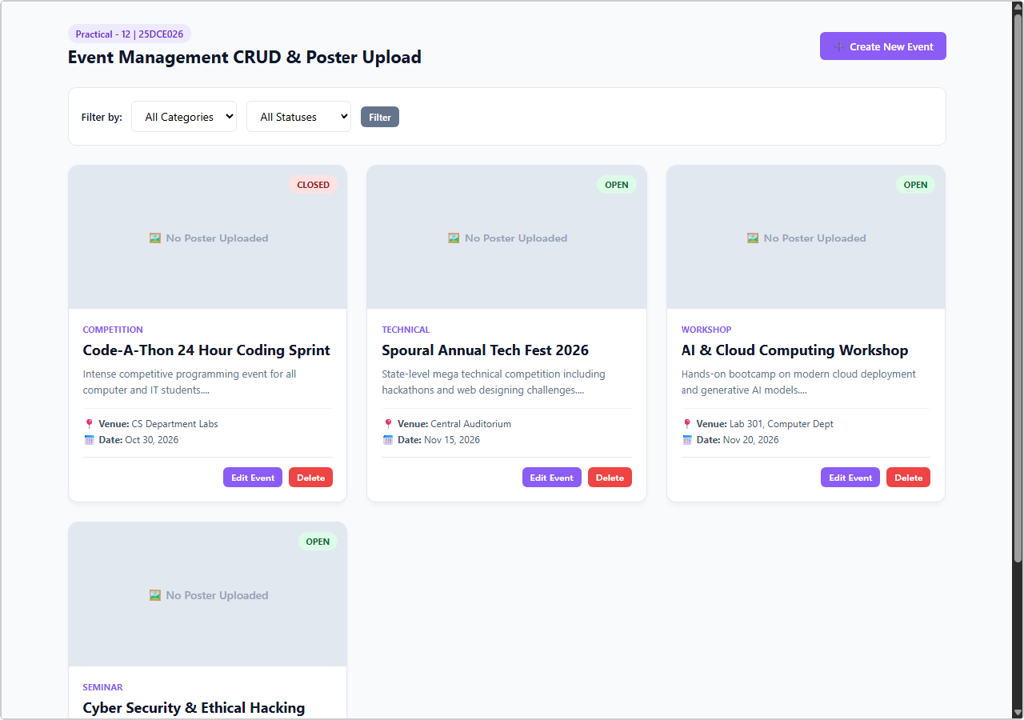
Output 1: Event Management Catalog with Uploaded Posters & Category Badges
Live browser screenshot: Responsive event card grid — Spoural Tech Fest, AI & Cloud Computing Workshop, Cyber Security Symposium, Code-A-Thon.

Output 2: Add Event Form with Poster Upload Controls
Live browser screenshot: Add Event form with title, category, description, event date, venue, and file input for poster upload.

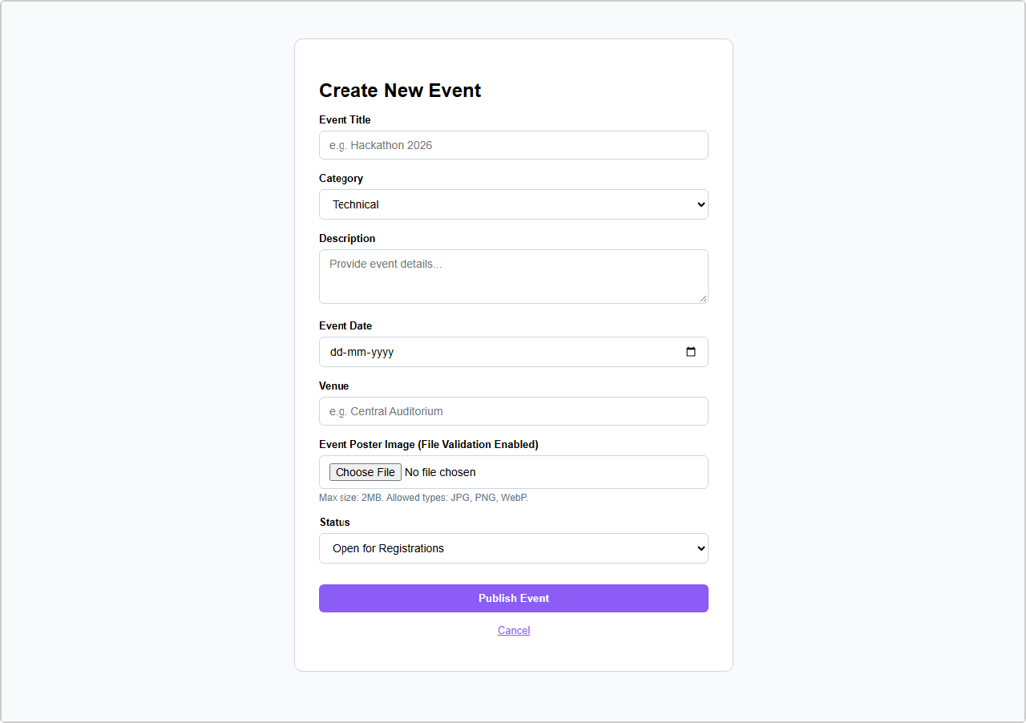

GitHub Repository Link:
https://github.com/bhavya13032007/studenthub/tree/main

Learning Outcomes:
- Developed a full Event Management CRUD portal in PHP and MySQL.
- Implemented server-side file inspection using PHP finfo MIME validation and size restrictions.
- Guarded against Arbitrary File Upload (AFU) vulnerabilities using cryptographic renaming and .htaccess
execution blocks.
- Maintained media storage integrity by automatically unlinking replaced or deleted poster images.
- Designed a responsive card-based event catalog with dynamic status and category badges.
- Integrated category and status filters for customized event queries.

